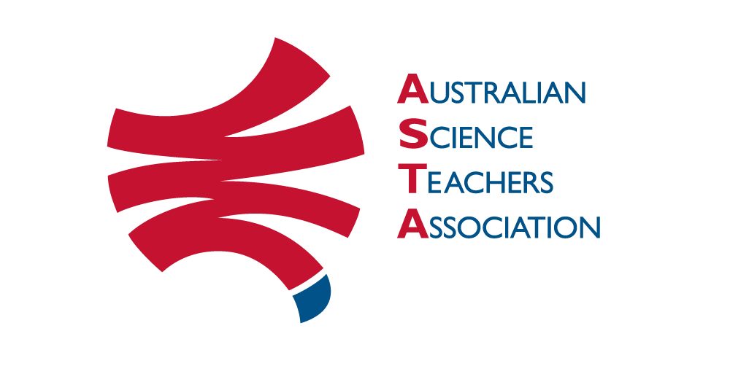

Science ASSIST: Expression of Interest
Science ASSIST is a national online advisory service for school science educators and technicians that has been freely available since 2014 because of Australian government funding. Science ASSIST is maintained by the Australian Science Teachers Association (ASTA). For more details see https://assist.asta.edu.au/about-assist.
In the absence of continued government funding, we need to progress to a subscription service from 2021. ASTA will charge an annual subscription of $150 per Australian school. By filling in this form for your school, you are expressing your interest in subscribing to Science ASSIST. Filling in the form will also enable us to confirm that there is sufficient demand for this service, where that demand is coming from and also give us an indication of the level of that demand.
If you are an individual, or not an Australian school, and you are interested in subscribing to Science ASSIST do not fill in this form. Instead, please contact us to express your interest through the following email address: asta@asta.edu.au
Please note that as long as the site remains available content added to the site prior to 1 July 2020 will remain publicly accessible as it was developed through funding made available by the Australian government. It is only new content and the advisory service that will require a subscription.
ASTA will contact your school soon via the contact listed below to provide you with a username and a one-time login to set a password and, later in the year, an invoice for 2021, subject to enough schools committing to a subscription.
Note: At current costings, 800 subscribers will be needed for the service to remain viable in its current form. If that number is not reached, Science ASSIST will no longer be a viable service for ASTA to continue.
* Required
School name*
School Address*
Suburb/Town*
Postcode*
State or Territory* | Please enter your Australian jurisdiction. If this doesn't apply, choose 'Other'  Australian Capital Territory New South Wales Northern Territory Queensland  South Australia Tasmania Victoria Western Australia Other
Region category | Please choose your region category from the list shown on this Australian Bureau of Statistics web page https://www.abs.gov.au/websitedbs/D3310114.nsf/home/remoteness+structure  Major city of Australia Inner Regional Australia Outer Regional Australia  Remote Australia Not sure
Institution Sector * | Please choose the closest appropriate category from the available list.  Government School Catholic School Independent School Other Institution
Institution Year Levels * | Please indicate their age range (e.g., K–6, K–12, 7–10, etc.)
Staff Usage* | How many staff in your school are likely to use the Science ASSIST service?  It’s just me 2-5 6-10 >10
Contact’s Name* | Please enter the name of the person in your institution best suited to act as a contact for Science ASSIST.
Contact's Email Address * | Please enter the email address of your institution's contact for Science ASSIST. This email address will also be the one used to set up subscriptions.
Contact's Role* | Please enter the role your contact has in your school.
Contact's Telephone Number | If your school's contact does not mind being contacted about this matter by phone, please enter their contact phone number, including the area code for landlines.
Terms of Use and Privacy Policy
The Terms of Use for the Science ASSIST website are available at https://assist.asta.edu.au/science-assist-website-terms-use
The Privacy Policy for the Science ASSIST website is available at https://assist.asta.edu.au/science-assist-privacy-policy

Please save this completed form with your school name and email to Teresa Gigengack at labsupport@asta.edu.au

